**Definitions**

|  |  |
| --- | --- |
| **Primary Key:** | A singular column or combination of columns (though not recommended) serves to uniquely identify a record (row) in a specific table. While multiple Candidate Keys may exist, only one of they can be the Primary Key. |
| **Candidate Key:** | Is any column or combination of such that can be used to uniquely all the rows of a table in a database. Hence there can be multiple Candidate Keys in a singular table but only one Primary Key. |
| **Super Key:** | Simply put is a “non-minimal” Candidate Key. Meaning it has the potential to uniquely identify each row in a table but may also contain information which does not serve this purpose. |

**Data Types Short Essay**

Data types exits in SQL Servers to serve as a way to minimize data entry error and ensure data consistency by limiting the type of value that the record of a particular field can hold. Some of the most common data types one might come across with are: Character Data, Date and Time Data, Integer Data, Binary String Data, Monetary Data, and etc. While extensive the list of Data Types that can be interpreted and inputted into a SQL Server are supplied by the Server itself, however with some Servers the user can define their own data types (Examples being Transact-SQL and Microsoft .NET Framework). The Data Type is assigned to the field during the creation of the table. (See example below)

For simplicity sake I will be using the example “Orders” table in our CAP3 database.

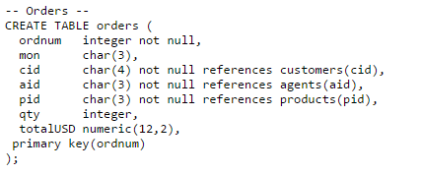

NN = Not Null

|  |  |  |  |  |  |  |  |
| --- | --- | --- | --- | --- | --- | --- | --- |
| **Orders** | | | | | | | |
| Ordnum | Mon | CID | AID | PID | QTY | TotalUSD | Primary Key |
| Int, NN | Char(3) | Char(3), NN | Char(3), NN | Char(3), NN | Int | Numeric | Key |

**Rules of Relational Databases**

1. First Normal Form
   1. Is the concept/rule that each attribute is atomic (i.e. indivisible). In other words this means that each attribute only contains a single value of data for that domain. In the cases of tables, each record only contains on value of data. This is important because it helps reduces inconsistencies in the data. In tandem with Data Types First Normal Form directs the user to input only a specific type of data and keep it atomic in nature, meaning the chances of user’s inputting data on a whim in whatever format they want is limited.
   2. 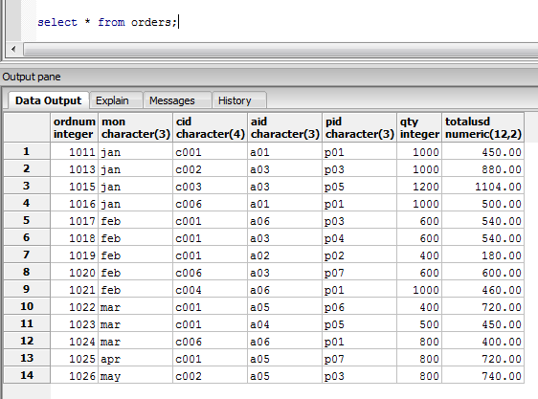
2. Access Rows By Content Only
   1. While the name implies exactly what the rule wants us to do it still bares the need for a little explanation. Accessing Content Rows, and by extension Columns, only by content allows for a more modular database. This means that the database is more flexible to change and modification. If in the backend of a program a row or column is accessed by its position, which is entirely possible, this setup might work so long as the format of the database does not change. But imagine if an extra row was added or a whole new column. The pointer to fetch the data does not adapt to that and will continue to point towards the same spot, where now a different piece of data resides.
   2. SELECT Column_name From user_tab_columns WHERE table_name = “My Table” and Column_id in (1,2,5)
      1. 
      2. Returns columns 1, 2, and 5
      3. But if the table is modified…
      4. 
3. All Rows Must Be Unique
   1. The anathema of good database design is data inconsistency, its close brother is data redundancy. All rows in a table must be unique to prevent this frugal waste of storage space. Also if data is entered multiple times then that increases the chance for data inconsistency, therefore by eliminating that possibility and enforcing this rule we can avoid the two major pitfalls of database design. To avoid this issue we can use foreign keys to instead of inputting data again.

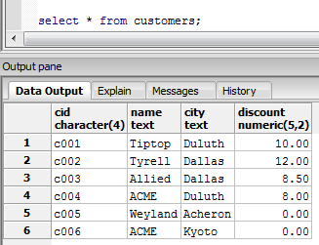

* 2. 
  3. The data inside the first row already exists elsewhere in another table. To fix this we could simply use foreign keys.
  4. 